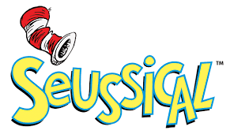

CONGRATULATIONS! Wanted to let you all know that this process was stupendously difficult and wonderfully enlightening. This was an amazing process. EVERYONE was so impressive.. Thank you for making this difficult.
CAST LIST

Check Back Later

\

Crew List

Check Back Later

